TALEND DI LEARNING GUIDE
File to file:
Creating connection with source file
Under repository tree we have metadata section
- Right Click on file delimited
- create file delimited
- Give file name
- Give input file location
- Give field separator and tick the checkbox for header.
- Next->finish
Create a job design
- Right Click on standard
- Give name and create
tfileinputdelimited:
purpose: used to read data from a delimited file.
tFileoutputDelimited:
purpose: component used to write data into a delimited file such as CSV, TSV, or any custom delimiter format.
usecase: creating db table using txt file
Configuration :
File name: provide file path to store output.
Field separator: provide field separator according to requirement(‘;’ ‘,’ ‘|’ ‘space’)
Include header: check this option to get header row as column.
Sync columns: click on this option.
Note: by default semicolon(;) is the field separator.
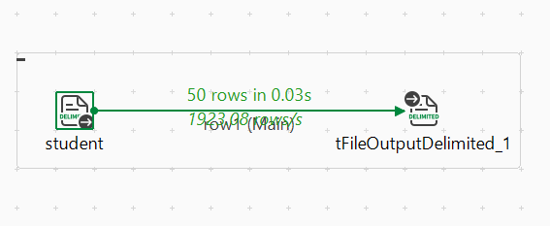
While changing the field separator we are getting error. To rectify it:
Click on output component---- go to advance settings untick the throw an error option.
Then run.
Tmap_1:
Component used to mapping between input and output flows
File to table:
Create new job as file_to_table
Drag tfileinputdelimited from metadata.
tfileinputdelimited:
purpose: used to read data from a delimited file.
tmap_1:
Purpose: used to give connectiin between input and output without giving schema .
tdboutput:
purpose: used to write data into a database table.
Configuration:
For tmap_1:
Connect with input file then map the column names then click ok
For tdboutput:
Version as 18-21
Give database connectivity
Give host name as “localhost”
Server as “xe”
Username as “system”
Password “root”
give action as create table if not exists.
Sync schema.
Tfileinputdelimited---> tdboutput
Tfileinputdelimited---> tmap_1---> tdboutput

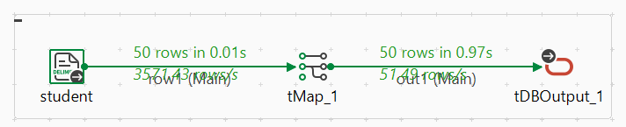

Table to file :
Metadate---> right click on dev ---> retrieve schema---> select table
Next click on table schema to select the table and drag that to workspace.
Give configuration to the table
Give version , host, database name, username, password.
Next select tfileoutputdelimited .
Then give configuration
- New file path with new name
- Field separator
- Include header
Then run.
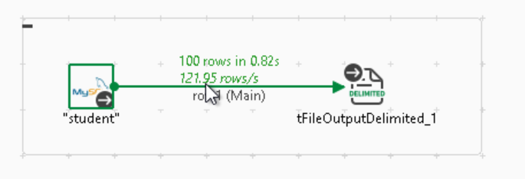

TLOGROW is used to check output in run console.

Table to table
Select table from metadata
Next give configuration.
Select tdboutput.
Set the configuration
Then give connection and run.
We can use t_map1 to sync the columns
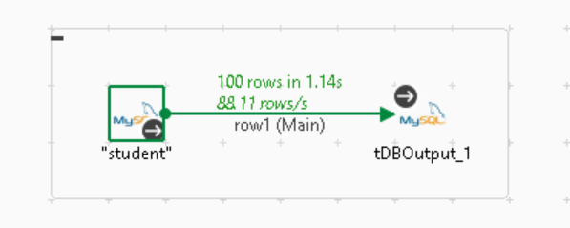
Tsamplerow_1
It is used to filter only specific rows
Here we need to specify range
You place tSampleRow after an input component
After specifying the rows we can get the output.
Ex: if we want to separate specific rows we use this(5, 10, 15 like this).

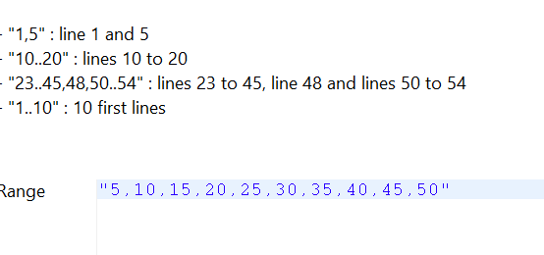
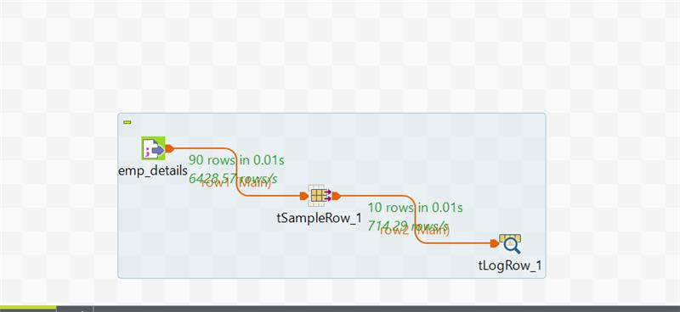

Tfilterrow_1
It is used to filter the data according to row names
In this we can specify the row according to which we want to filter.
Drag tFilterRow into your job after tFileInputDelimited.
Open tFilterRow and go to the Components tab.
Give condition. Then connect it with the output.

For skipping specific number of rows
If we want to remove 1st 10 rows then at output we need to need specify the header as 11.
For last rows we need to change footer.

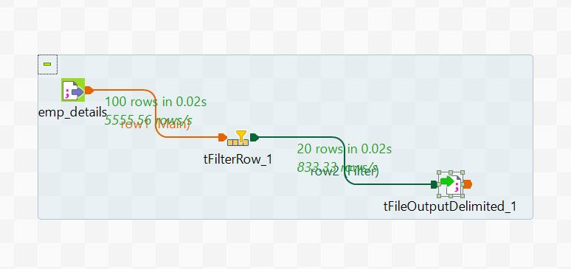

split the data from the file
Take input file from file delimiter
Take output as tfileoutputdelimiter
In components go to advanced settings
Check the tick box split output into several columns
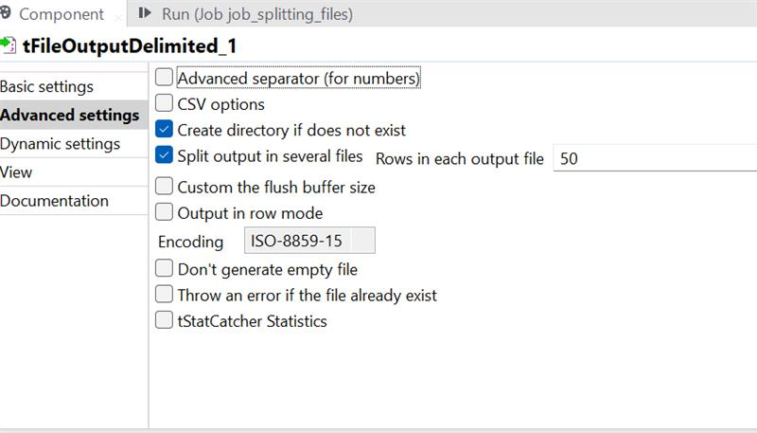
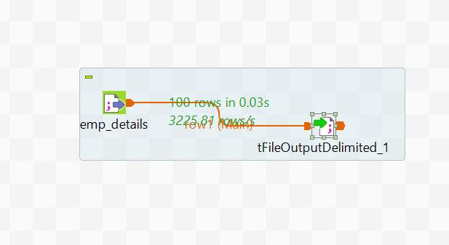
Combining the data from files:
Here we can only combine the data which are of same schema.
Here we use tunite component to combine the data .
In this we give more than 1 input files and combine them using tunite component.
This component gives the output to tlogrow or tfileoutputdelimit or anyother output components.
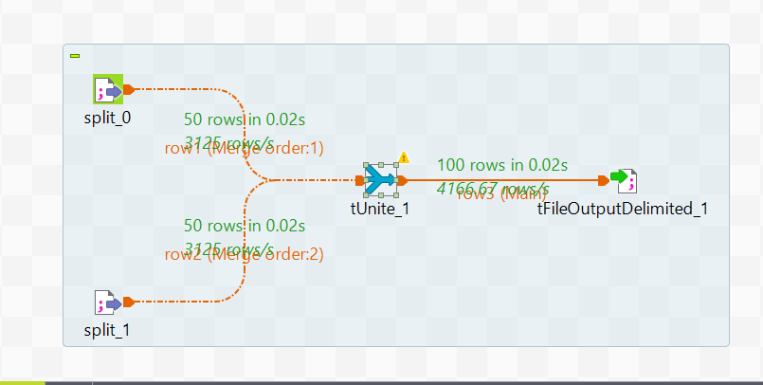

Tuniqrow:
It is used to fetch the unique rows in files or tables.
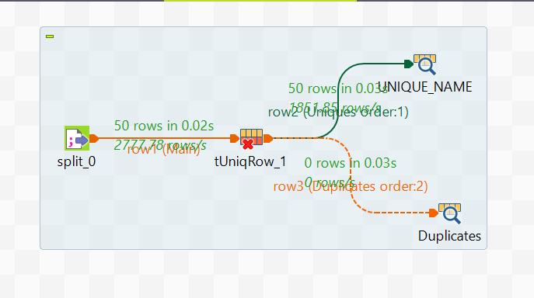
Tfiledelete:
It is used to delete files from the specified locations.
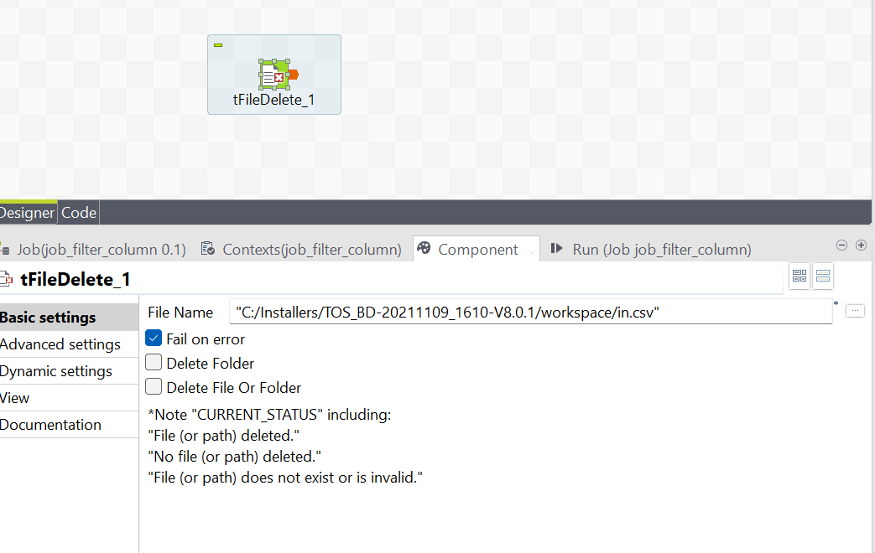

Tfilecopy:
It is used to copy the files from one location to other .
In this we can delete the source file from where have copied the file.
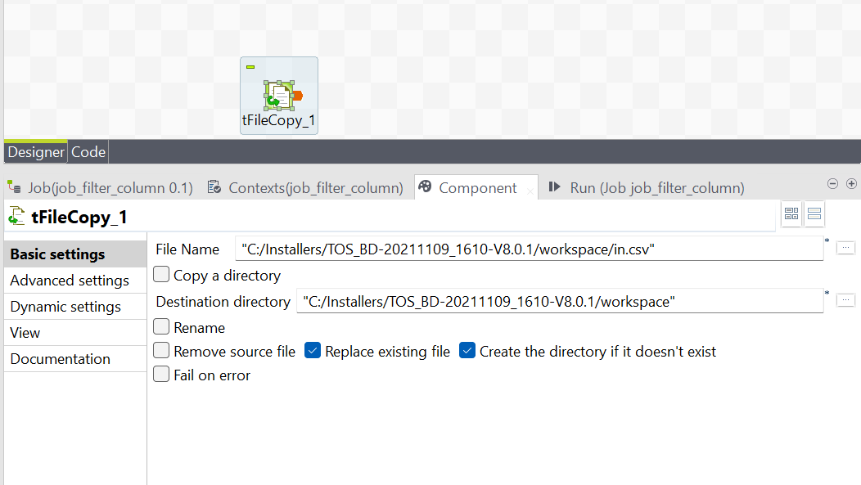

Tfilearchive:
Creates an archive file (like .zip, .gzip, or .tar.gz) from one or more files or folders.
Tfiltercolumn:
This is used to filter the columns.
In this we can specify the columns which we want to delete.
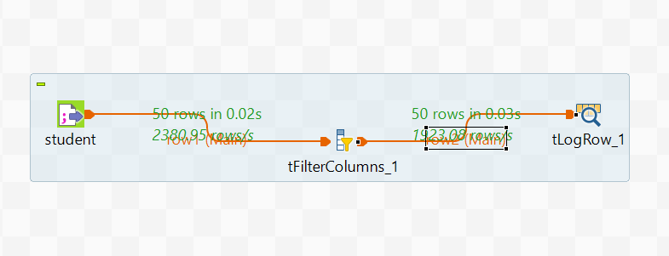
Tsortrow:
This is used to arrange the data in assending and descending order by specifying the columns.
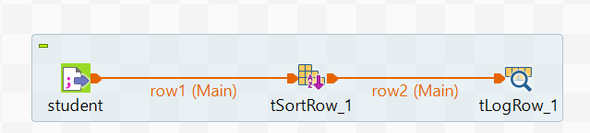

Scenario to access highest data
In below image we have found 2nd highest marks.
From student input file we have accessed the data .
When input data is give to tuniqrow, the duplicates can be removed.
Then the tsortrow is used to sort them in desc order to get the highest values.
By using rsamplerow we can directly access the 2nd highest value.
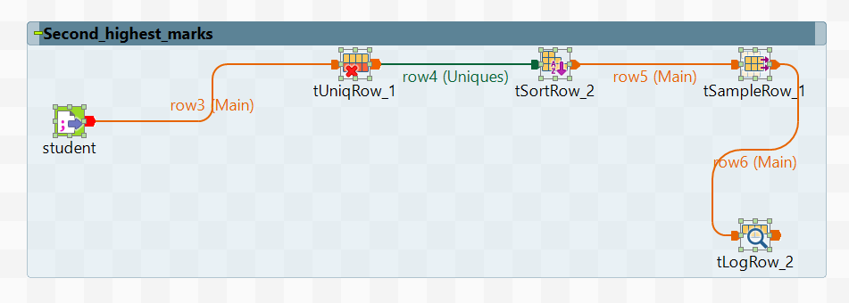

Tfilelist
In tfilelist we can read specific file from directory using filemask.
tFileList goes through all the files in a folder one by one.
For each file, it saves the full file path in global variable that other components (like tFileInputDelimited) can use to read that file.
Directory: Specify the folder path
FileList Type:
- Files → iterate over files only.
- Directories → iterate over folders only.
- Both → iterate over both.
Include Subdirectories: Option to include nested folders.
Filemask: Use patterns like *.txt or *.* to filter files.
Connect tFileList to a component like tFileInputDelimited.
Use the variable ((String)globalMap.get("tFileList_1_CURRENT_FILEPATH")) to read each file dynamically.
load data into your target system like tlogrow, tfileoutputdelimited, tdboutput.
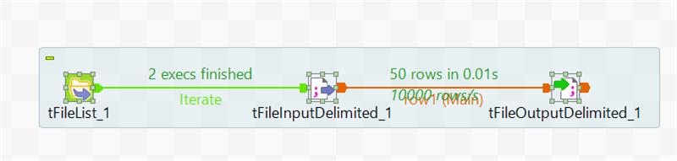

Twaitforfile:
component used to pause a job until a specific file event happens in a directory.
It monitors a folder and waits for a file to be created, updated, or deleted.
Once the condition is met, it triggers the next component in the job.
Directory to scan: Specify the folder to monitor.
File mask: Filter files (e.g., *.csv or exact file name).
Rigger conditions:
- File created
- File deleted
- File updated
- Any of the above
Loop control:
- Continue checking after triggering
- Exit loop immediately
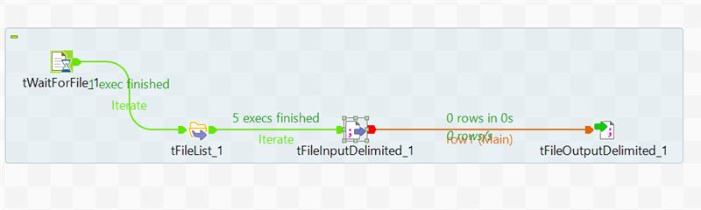
tNormalize:
Drag tNormalize into your job.
Connect it to the component that provides the input (e.g., tFileInputDelimited).
Double-click tNormalize to configure:
- Column to normalize: Select the column with delimited values (e.g., Products)
- Item separator: Specify the delimiter (e.g., ;)
Connect the output to a component like tLogRow, tFileOutputDelimited, or tMap.
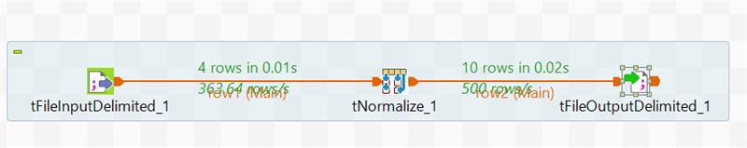
Tdenormalize
Drag tDenormalize into your job.
Connect it to the input source (e.g., tFileInputDelimited or tMap).
Double-click tDenormalize to configure:
- Group by column(s): Choose the key column(s) (e.g., ID)
- Denormalize column(s): Select the column to aggregate (e.g., Sales)
- Delimiter: Choose a separator (e.g., ;, ,, or |)
tFileInputDelimited → tDenormalize → tLogRow
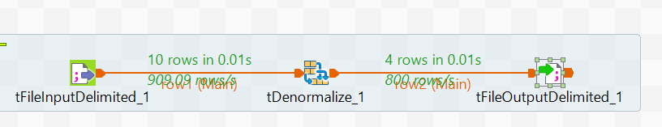

Tfileproperties:
In Talend Studio, tFileProperties is a component used to extract metadata about a file, such as its name, path, size, and last modified date.
File Name/Path: Full path to the file you want to inspect (e.g., C:/data/report.csv)
tFileList → tFileProperties → tLogRow

Taggregaterow

Treplicate :
It is used to copy the data from one file to multiple files in single run.
tReplicate takes a single input and creates multiple identical outputs.
tFileInputDelimited
|
tReplicate
/ | \
DB File tLogRow
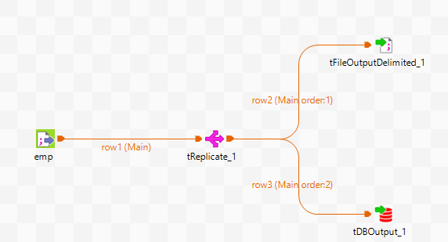
Dynamic load:
Dynamic load means your Talend job can handle files or data with changing columns — without needing to change your job every time.
- Tflowtoiterate:
It takes a list of rows (like from a file or database) and turns them into a loop — so Talend can work on one row at a time.

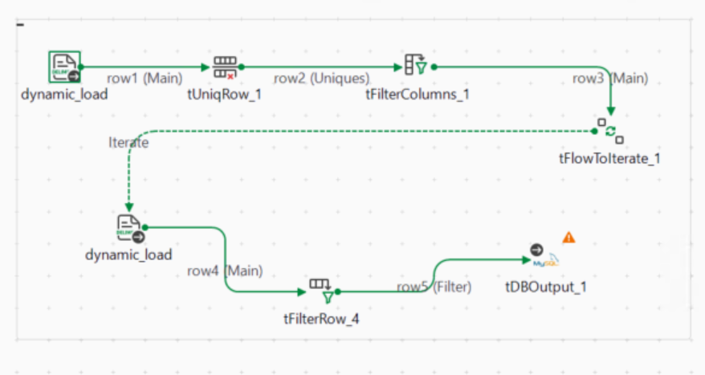
Tuniqrow configuration
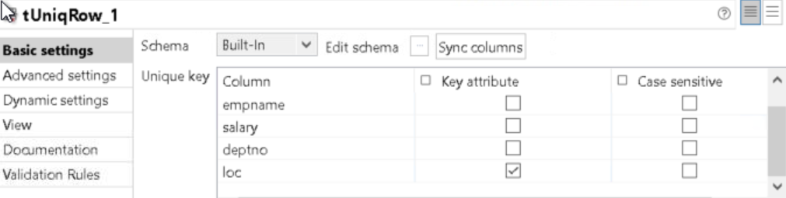
Tfiltercolumn configuration
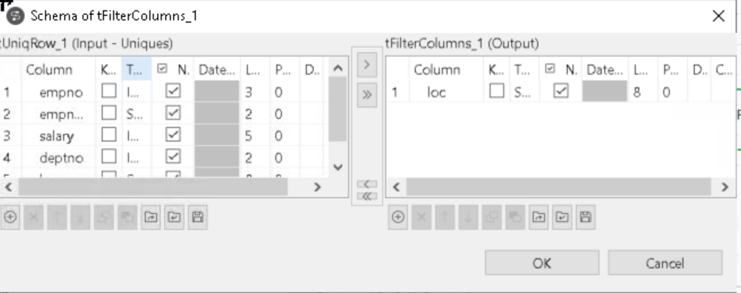

Tfilterrow configuration
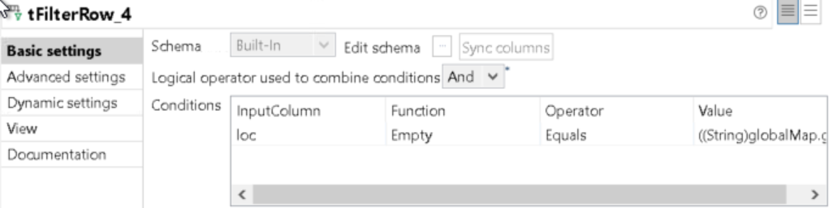
OnSubjobok ,onSubjoberror:
In Talend, OnSubjobOk and OnSubjobError are trigger connectors used to control the flow of execution between subjobs based on success or failure
Onsubjobok
Triggers the next subjob only if the 1st subjob completes successfully
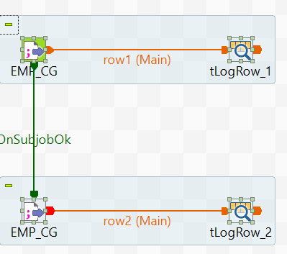
OnSubjobError
Triggers the next subjob only if the 1st subjob fails.
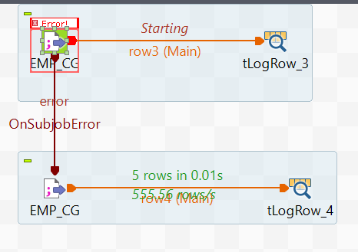
Tdbcommit:
It saves all the changes made to the database since the last commit.
After a series of successful database operations (like inserts or updates), use tDBCommit to make those changes permanent.
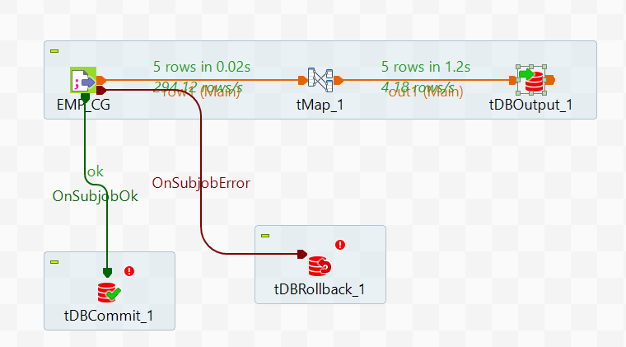

Tdbroleback:
It undoes all changes made to the database since the last commit.
If something goes wrong (like an error or exception), use tDBRollback to cancel the changes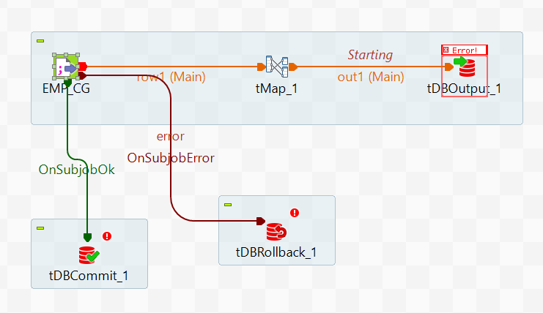

Tmsgbox:
It is a component in Talend that shows a pop-up message box when your job runs.
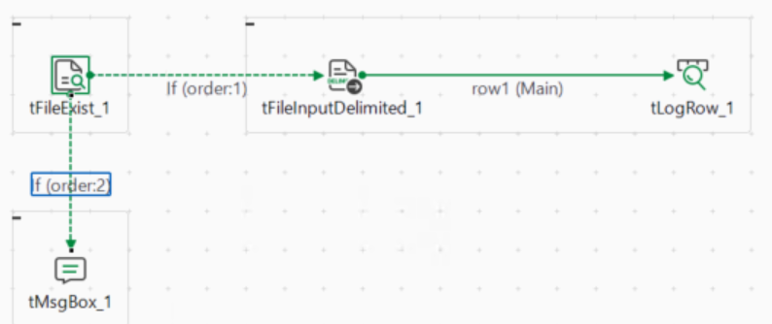
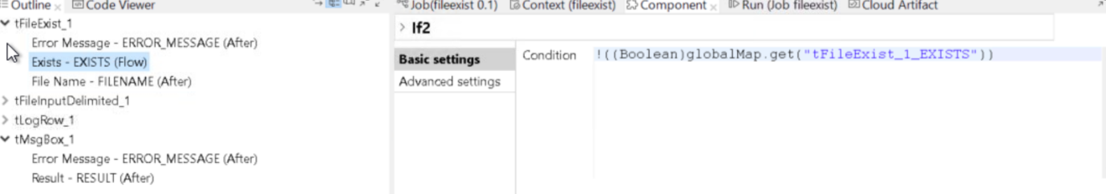
Tjava:
Talend component that lets you write and run custom Java code inside your Talend job.

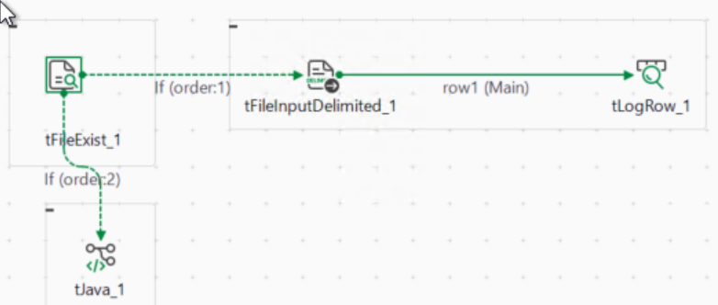

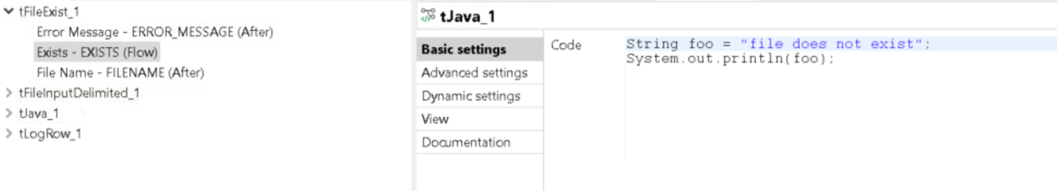
Tsendmail:
in this if we get error in 1st job then tsendmail will execute .
to make it execute we need to check die on error box.
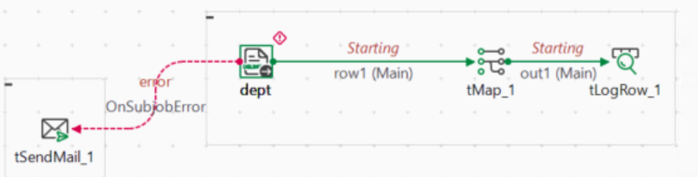
- Tsendmail configuration:

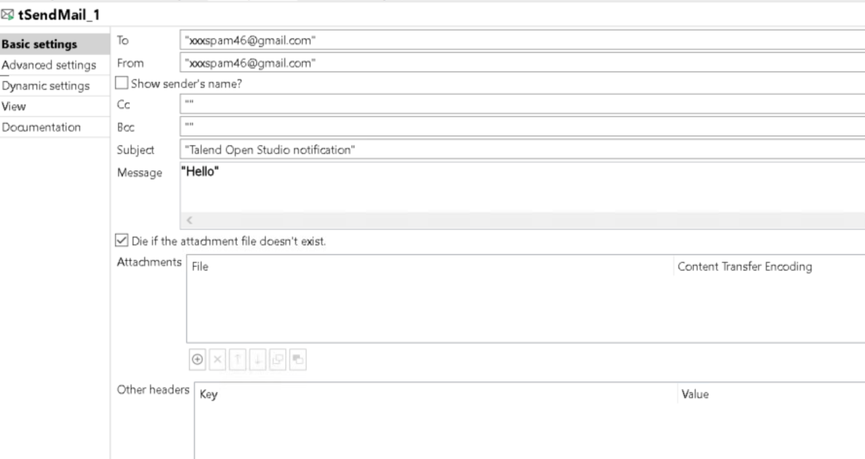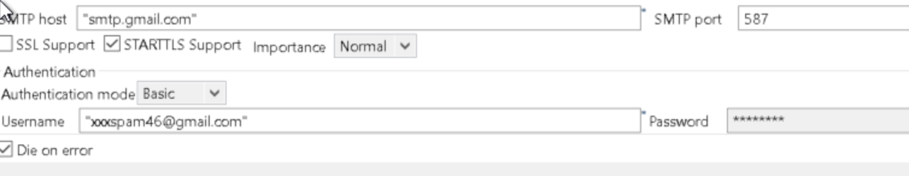

Parent to child job:
A Parent-Child Job relationship refers to a setup where one job (the parent) calls and executes another job (the child) during its execution.
- Parent Job: The main job that controls the overall process.
- Child job: A sub-job

Step 1: Create the Child Job
- Create a new Job (e.g., ChildJob).
- Add a tJava component.
- In the tJava component, write code to access and print context variables passed from the parent:
System.out.println(context.name+" got "+context.marks);
- Define context variables in the child job:
- Go to the Context tab.
- Add variables like name and marks with appropriate data types (e.g., String, Integer).

Step 2: Create the Parent Job
- Create a new Job (e.g., ParentJob).
- Add and configure the following components:
  - tFileInputDelimited: to read employee data from a CSV or text file.
    - Define schema with fields like id,name, marks, etc.
  - tFlowToIterate: to convert each row into a set of variables.
  - tRunJob: to call the child job for each row.
- Connect the components:
  - Link tFileInputDelimited → tFlowToIterate using Row > Main.
  - Link tFlowToIterate → tRunJob using Row > Iterate.
- Configure tRunJob:
- Select the child job you created.
- Go to the Context Param section.
- Map parent values to child context variables:
name = ((String)globalMap.get("row1.name"))
marks = ((String)globalMap.get("row1.marks"))
For each row in the input file, the parent job will:
- Extract name and marks
- Pass them to the child job
- The child job will print or process them using tJava
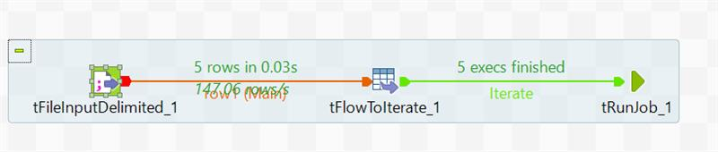
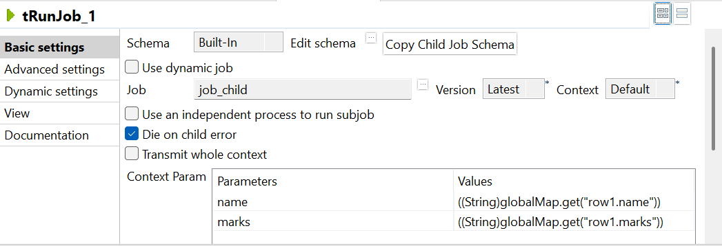

Child to parent:
Step-1 : child job
Components:
- tFileInputDelimited
  - Reads a file with columns: id, name, marks.
- tLogRow
  - Displays the input data for verification.
- tFixedFlowInput
  - Generates a summary or static row (e.g., no_lines).
- tBufferOutput
  - Sends the data from tFixedFlowInput back to the calling job.
Flow:
- tFileInputDelimited → tLogRow
- tFixedFlowInput → tBufferOutput
- Use OnSubjobOk to trigger tFixedFlowInput after tFileInputDelimited finishes.

Step-2: parent job
Components:
- tRunJob
  - Calls child job
- tJavaRow
  - Processes or logs the returned data from Job A.
  - Example:
  - System.out.println("Received from child: " + input_row.status);
Flow:
- tRunJob → tJavaRow (Row → Main)

✅ Result
- Job A reads and logs the input file (id, name, marks).
- After processing, it sends a summary row (e.g., status, timestamp) using tBufferOutput.
- Job B receives this row and processes it in tJavaRow.

How to improve performance in job
- Under job tab we have multi thread execution -- >By enabling multi thread execution
- Parallel execution on iterare link
- tparalleize
- Under run tab in advance setting we have Jvm in this we can specify the memory size(jvm arguments xms265m, xmx1024m)
- store temp data true in tmap component
compress file as zip
remove unwanted columns
tlogcatcher: Captures error messages, warnings, and logs
tstarcatcher: used to catch the status of job.
Collects runtime statistics like row counts, execution time, and component status.
Tdie: Stops the job immediately when a critical error occurs.
Twarn: Logs a warning message without stopping the job.
Tflowmeter:
Tcontextload: used to dynamically load context variables from an external source like a file or database at runtime.
- Reads key-value pairs from a file (e.g., CSV, properties) or input flow.
- Updates existing context variables in your job with the loaded values.
- Allows dynamic configuration without editing the job.
📄 Example: Loading from a CSV File
Suppose you have a file context.csv:
key;value db_host;localhost db_port;3306 db_user;root db_pass;root
Steps to Use tContextLoad:
- Create context variables in your job:
  - db_host, db_port, db_user, db_pass
- Use tFileInputDelimited to read context.csv
  - Set delimiter to ;
  - Define schema: key (String), value (String)
- Connect to tContextLoad
  - Link tFileInputDelimited → tContextLoad
  - In tContextLoad, set:
  - Field for key: key
  - Field for value: value
  - Enable “Print operations” to debug what’s being loaded
- Use context variables in your job
- For example, in tDBConnection, use context.db_host, context.db_user, etc.
Tprejob:
Tprejob- tfiledelimited-tcontextload---tdbconnection
Tpostjob-tdbclose
Treplace: we replace the values unsing this
Using tmap we can join more than 2 sources in that one is source and other are lookups and can do all types of joins and can perform many transformations like string handling
Using tjoin we can only join 2 sources and can only perform only inner join.
tSystem :
component in Talend is used to execute system-level commands or scripts directly from within a Talend job
tloop: repeating a set of actions multiple times based on a condition.

